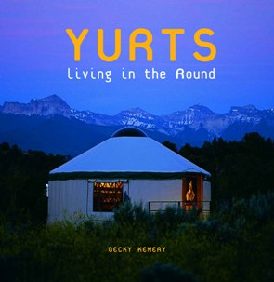

YURTS: Living in the Round

slide presentation with author
becky kemery

and special guests
Kathy Anderson & Sharon Morley
of Blue Ridge Yurts

Tuesday Jan. 10, 6 pm

Xaltemba Restaurant

YURTS: Living in the Round

slide presentation
with author
becky kemery

and special guests
Kathy Anderson & Sharon Morley
of Blue Ridge Yurts

Tuesday Jan. 10, 6 pm

Xaltemba Restaurant

YURTS: Living in the Round

slide presentation with author
becky kemery

and special guests
Kathy Anderson & Sharon Morley
of Blue Ridge Yurts

Tuesday Jan. 10, 6 pm

Xaltemba Restaurant

YURTS: Living in the Round

slide presentation
with author
becky kemery

and special guests
Kathy Anderson & Sharon Morley
of Blue Ridge Yurts

Tuesday Jan. 10, 6 pm

Xaltemba Restaurant

